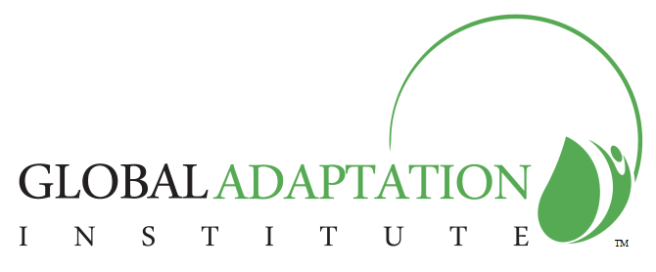

**Measuring what Matters – Attracting Private Investment in Adaptation**

All countries are struggling with the challenges of adaptation to climate change and other global forces, such as urbanization and population growth. Developed countries have the resources to create successful public/private investment opportunities to address these urgent issues and improve and save lives. In the developing world, public sector investments in adaptation fall far short of meeting the existing need to protect the most vulnerable, however, opportunities to attract private sector investments are beginning to be identified.

The Global Adaptation Index™ v 1.0 is being created as the world’s first index to shine light on opportunities for private sector engagement in adaptation. The Index also highlights changes governments can make now to attract private investment.

**Adaptation Can’t Wait – Open Consultation**

GaIn™ v 1.O was created by the nonprofit Global Adaption Institute over the past twelve months in consultation with experts from around the world and the Institute’s Council of Scientific Advisers. Before release of the Index to the public, the Institute is requesting additional review and comment on a redacted version of the Index through this open consultation process.

Participate in Open Consultation